DUBAI HEALTH
ERROR MANAGEMENT HUB
Architecture Proposal
Unified Support Workspace
Enterprise Architecture • Solution Architecture • Security • Deployment • Implementation

Document Attribute | Value
Version | Version 1 (v1)
Status | For Approval
Date | 15 June 2026
Classification | Confidential — Internal Use Only
Primary Platform | Mendix
Deployment Baseline | On-Premises — Mendix
Audience | Solution Architect, Application Owners

Document Control
Item | Detail
Document Owner | Solution Architecture — Vikram
Business Owner | Error Management Hub Product Owner — Ahmed Taha
Technical Owner | Mendix Application Owner — Safaa Soliman
Security Owner | Information Security Team
Approval Authorities | Solution Architecture, Security, Infrastructure, Operations
Scope | Phase 1: User Management, Clinical Attachment, Premarital, Patient Services, Audit Management and Operational Logging
Out of Scope | Transactional updates to source systems and bulk export

Version | Date | Owner | Description
1.0 (v1) | 15 June 2026 | Solution Architecture | Architecture Proposal

Contents
- 1. Solution Overview
- 2. Data Architecture
- 3. Application Architecture
- 4. Technical Architecture & DevSecOps
- 5. Information Security Architecture
- 6. Implementation Approach
- Appendices A–D

1. Solution Overview
The Error Management Hub (EMH) is a secure, internal support investigation workspace implemented on Mendix. It gives authorized support personnel one role-appropriate entry point for locating and viewing diagnostic information held by multiple Dubai Health systems. Phase 1 does not update source-system records.
Architecture Dimension | Target Position
Business capability | Unified read-only investigation for user access, clinical attachment, premarital and patient-service issues.
Application style | Modular Mendix monolith with capability-aligned modules and shared platform services.
System boundary | Mendix owns presentation, orchestration, access enforcement, configuration and minimized operational evidence; source systems own business data.
Integration style | Synchronous REST APIs consumed over approved enterprise connectivity. No direct source-database access.
Identity | IDAM SSO; OIDC is confirmed
Data strategy | Non-persistable entities for external responses; persist only EMH-owned data with explicit retention.
Deployment | EMH will be deployed within the organization’s existing On-premises mendix platform, using the approved environment, release-management, security, monitoring, backup, and operational standards.
Operations | Enterprise ingress, database, registry, secrets, monitoring, SIEM, backup and DR integrated with Mendix runtime operations.

1.1 Business Purpose
Support teams currently investigate incidents by navigating disconnected applications, calling APIs manually or relying on technical teams to query data. This increases resolution time, creates inconsistent evidence and may expose more information than the support purpose requires. EMH addresses the problem by standardizing how an authorized user searches, views and interprets current source-system information.
Business Objective | Architecture Response | Measure / Evidence
Reduce investigation time | Single hub, common search patterns and normalized result presentation | Median investigation time and number of systems opened per investigation
Reduce technical dependency | Approved API connectors replace manual database/API assistance | Percentage of supported investigations completed without developer/API handover/DBA involvement
Protect confidential data | Least-privilege roles, non-persistence and privacy-safe audit | Access reviews, privacy tests, audit sampling and zero raw-sensitive-value logging.
Improve consistency | Reusable search, validation, error and result components | Common UX standards and acceptance evidence across all modules
Improve traceability | Record who used which investigation function and when | Audit completeness and reconciliation against runtime/security logs.
Isolate source-system failures | Each module handles its API failures without taking down the hub | Module-level availability and graceful-degradation tests.

1.2 Solution Summary
The solution consists of a Mendix responsive web application, an IDAM SSO integration, consumed REST connectors to the external business and identity services, a small Mendix-owned operational data model and an on-premises runtime platform. EMH defines the approved Mendix user roles and module roles for the application; these roles are registered in IDAM as approved EMH application groups or access claims. During OIDC login, IDAM returns the authenticated user identity and approved EMH role/group claims. EMH maps these claims to native Mendix user roles and module roles, and the user sees only the application areas allowed by the resulting Mendix security model.
Layer / Capability | Implemented in Mendix | Implemented Outside Mendix
User experience | Responsive shell, application hub, role-based navigation, search pages, result/detail pages, validation, access-denied and unavailable states. | DNS, user network and enterprise ingress.
Business orchestration | Microflows coordinate validation, authorization context, API invocation, response mapping, AuditOutbox submission, delivery status handling and user-safe error handling. | Business processing, status transitions and transaction history remain in source applications.
Data | Native Mendix Account/User/Role model for access; approved IDAM roles mapping attributes on Mendix Account where required; non-persistable response models for source data. | Clinical attachment, identity, premarital, payment and patient data; Enterprise Audit Repository for official audit evidence; operational exception logging; APM monitoring; database backups.
Identity and access | EMH-defined Mendix user roles and module roles mapped from approved IDAM groups or OIDC roles; Mendix page access, microflow access and entity access enforce authorization. No separate custom authorization model. | IDAM authentication, account lifecycle, MFA, roles assignment.
Integration | Consumed REST definitions, import mappings, headers, correlation, response translation and controlled audit-event submission to the Enterprise Audit Repository | API implementations, gateway, service authentication, network routing, source-system SLAs(source system fails,rate limiting, slowness) and enterprise secret management
Operations | Runtime configuration references, correlation-ID generation, controlled retries and user-safe error handling | WAF, source system secrets, approved APM monitoring, centralized exception logging, SIEM, backup, DR and enterprise audit repository operations.

1.3 Key Architecture Decisions
ADR | Decision | Status | Rationale
ADR-001 | Adopt Mendix as the primary application platform | Approved | Provides one governed platform for the user experience, orchestration, security model and EMH-owned persistence.
ADR-002 | Use a modular Mendix monolith organized by business capability. | Approved | EMH Phase 1 is a read-only support investigation workspace; the scale and coupling do not justify independently deployed distributed services.
ADR-003 | External source systems remain the official owners and systems of record for their data. EMH retrieves data at runtime for authorized support investigation only and does not duplicate, or modify source-system business data | Approved | Prevents duplication and preserves ownership.
ADR-004 | Use API-only source access | Approved | Direct database reads are prohibited and would bypass ownership, security and contract controls.
ADR-005 | Use non-persistable entities for external operational responses | Approved | Minimizes confidential data retention and schema coupling.
ADR-006 | Use native Mendix security as the EMH authorization enforcement boundary | Approved | Approved IDAM groups or OIDC role claims are mapped to Mendix user roles and module roles. Page access, microflow access and entity access are enforced by Mendix and are not duplicated in custom permission tables.
ADR-007 | Use IDAM SSO, lifecycle and EMH role/group claims | Approved | Authentication, user lifecycle and approved EMH role/group entitlement belong to IDAM. OIDC is confirmed, and required user attributes and role/group claims are returned by IDAM for mapping to Mendix roles.
ADR-008 | Deploy Mendix  - On-Prem Azure Dev Ops due to security constraints | Approved | Meets residency/security/control requirements
ADR-009 | EMH will call source systems using synchronous REST APIs because support users need immediate search results. If one source system is unavailable, only the related module should show a controlled unavailable message while the rest of EMH remains usable. | Approved | Search interactions need immediate responses and must isolate failures.
ADR-010 | - Data Will be stored Relational Database SQL Servers | Approved | Data will be stored in relational databases using SQL Servers. Database will enforce integrity and referential constraints to ensure data accuracy and consistency. Integrity constraints, such as primary keys and unique constraints, will maintain the correctness and validity of the data.
ADR-011 | No Phase 1 export of investigation data | Approved | Export creates uncontrolled copies of confidential and highly confidential data. Any future export must be approved through a separate ADR and privacy review.
ADR-012 | Use Elasticsearch for sanitized exception logging and runtime diagnostics. |  | Exception logs require searchable operational analytics. Elasticsearch stores sanitized exception messages, error metadata and correlation IDs only. It is not an audit repository and must not store sensitive payloads, tokens, credentials or search values.
ADR-013 | Use AppDynamics for application performance monitoring and runtime health. |  | Operations require runtime visibility, response time, dependency latency, availability and error-trend monitoring. AppDynamics is used for APM monitoring only and is not the exception-log store or audit record system.

1.3.1 Architecture Principles Applied
Principle | Application to EMH | Architecture Consequence
API First | Every source capability is exposed through an owned, versioned API contract | No external database connectivity and no screen scraping.
Secure by Design | Security requirements shape pages, flows, data and operations from the start | Deny-by-default roles, server-side access rules and audit.
Least Privilege | Users receive only the EMH access groups/claims approved in IDAM and the corresponding Mendix user roles and module roles required by their support duties. | Access is enforced by Mendix page, microflow and entity security
Data Minimization | External systems responses | NPE-first design; no local source-data tables
Resilient Integration | Failures are bounded and isolated by external service | Timeouts, idempotent retry, graceful messages, correlation and health monitoring.

1.4 RAID Logs
ID | Type | Description | Impact | Response / Required Decision
R-01 | Risk | Source APIs fail or respond slowly | High | Per-module degradation, timeout, one idempotent retries and operational alerts.
A-01 | Assumption | Phase 1 is read-only investigation | High | Any write operation requires a new security/data/integration decision.
A-02 | Assumption | Source owners provide stable REST APIs and test data | High | Formalize interface contracts and readiness gates.
A-03 | Assumption | Three segregated environments are available | Medium | Confirm Development, Test and Production platform capacity.
I-01 | Issue | Some external systems APIs api not exist | High | Block final connector implementation until owner and contract approval.
D-01 | Dependency | EMH production readiness depends on the availability and configuration of the required Infrastructure, database, security, DNS/certificates, secrets and monitoring teams | Critical | Confirm the required Mendix runtime capacity, db, DNS, TLS, certificates , firewall rules, secrets , monitoring and DR and network connectivity before production deployment
D-02 | Dependency | EMH Integrate with Other External systems or DHAC systems | High | support will be required from respective team, and their slowness,downtime might affect proper functioning of the application

1.5 Architecture Gaps
Sl No | Architecture Domain | Gap | Description
AG-1 | Business Architecture | Customization Limitations | Mendix’s low-code nature may limit the ability to implement highly customized business processes that deviate significantly from standard practices
AG-2 | Technical Architecture | Vendor Lock-In | Dependency on Mendix’s proprietary platform could pose challenges if there is a need to migrate to another platform in the future.
AG-3 | Technical Architecture | Integration Complexity | Integrating Mendix Runtime with other enterprise systems and services might require custom connectors or middleware.
AG-4 | Information Security Architecture | Data Security | Ensuring that data is adequately protected, especially when dealing with sensitive information, By Development mis practice a sensitive information might get exposed or get operated upon without necessary Authorization

1.6 Stakeholders & Concerns
Stakeholder | Primary Concerns | Architecture Response
Business Owner | Resolution time, scope value, adoption and delivery risk | Reusable application/modules
Support Officer | Fast search, clear results, minimal navigation and useful errors | Search/result patterns and clear error messages
Enterprise Architecture | Standards, reuse, ownership and future evolution | Mendix reference patterns, API-only boundaries and traceability
Information Security / Privacy | Confidential data, access, vulnerabilities, logs and residency | SSO, security tests and on-prem deployment
Application / API Owners | Contract stability, load, ownership and error handling | Bounded calls, no direct DB access and no direct API calls
Operations / SOC | Monitoring, incidents, supportability, retention and recovery | APM monitoring, exception logging, SIEM integration, runbook, sanitized logs, backup/restore and DR exercises

2. Data Architecture
Data Architecture defines how information is accessed, represented, protected, retained and governed within the Error Management Hub (EMH).
EMH is designed as a secure support investigation workspace. It does not become a secondary master repository for identity, patient, clinical, payment or application data. Source-system information is retrieved on demand through approved APIs, mapped into Mendix non-persistable entities, displayed only to authorized users within the active investigation context and not persist in EMH after use.
Authentication, user lifecycle and EMH role entitlement remain with IDAM. EMH maps approved IDAM groups or role claims to native Mendix user roles and module roles. Authorization enforcement inside EMH is performed through Mendix native security, including users, user roles, module roles, page access, microflow access and entity access. EMH does not maintain a separate custom authorization database or permission table.

2.1 Data Scope, Glossary & Reference
This section defines the scope of data handled by EMH, the conceptual and logical data model, and the business glossary for the principal information objects used by the solution.

2.1.1 Conceptual Data Model & Data Glossary
The conceptual data model separates Mendix-owned runtime platform data, temporary audit-delivery data, transient investigation views and external authoritative systems. EMH does not maintain a business data repository for the information it investigates.
Conceptual Domain | Core Data Objects | Persistence Type | Relationship / Meaning
Mendix Security Model | Mendix Account, User Roles, Module Roles, Page Access, Microflow Access, Entity Access | Mendix platform-managed persistence | Mendix provides the application authorization model. EMH uses native Mendix security as the enforcement boundary after approved IDAM role/group claims are mapped to Mendix roles. No separate EMH permission engine is introduced.
Minimal IDAM Mapping | IDAM Subject Identifier, Display Name, Email, Account Status, Last Login Timestamp, Last Synchronization Timestamp, Approved EMH Role/Group Claim References where required | IDAMUserInfo persistable Mendix entity | Used for SSO mapping, role/group claim mapping, user display and access review. IDAM remains the identity and entitlement source. Sensitive identity attributes are not stored in EMH.
Temporary Audit Delivery | AuditOutbox | Temporary persistable Mendix entity | Holds privacy-safe audit events awaiting acknowledgement from the Audit Repository.
User Investigation Views | IDAMUserView, UAEPassIdentityView, IDAMAccessView | Non-persistable Mendix entities | Created from IDAM/UAE PASS API responses for the active support investigation and discarded after use.
Clinical Attachment Investigation Views | ClinicalAttachmentApplicationView, ClinicalAttachmentDetailView, ICPApplicantView, ClinicalResponsibilityView, ReferenceView | Non-persistable Mendix entities | Created from Clinical Attachment and related API responses. Parent/detail relationships exist only in memory or page context.
Premarital Investigation Views | PremaritalApplicationView, PremaritalPaymentView | Non-persistable Mendix entities | Provisional runtime views subject to approved Premarital API contracts. No Premarital business data persisted by EMH.
Patient Services Investigation Views | HealthCardView, SickLeaveView, MedicalReportView | Non-persistable Mendix entities | Runtime-only support views for Patient Services investigations. No patient records, medical report documents or clinical content are stored in EMH.

2.1.2 Logical Data Model
The logical data model identifies the data structures used by EMH. Persistable Mendix data is minimized. The application relies on native Mendix security for users and roles, externalized configuration for runtime parameters and non-persistable entities for all source-system response views.

2.1.2.1 Persistable Mendix Entities
EMH does not store source-system documents, medical reports, clinical attachments.
Entity | Persistence Type | Purpose | Key Attributes | Relationships | Retention / Notes
Mendix Account | Platform-managed persistable entity | Represents authenticated application users within the Mendix security model. | Native Mendix account attributes; optional IDAMSubjectId, DisplayName, Email, AccountStatus, LastLoginAt, LastSyncedAt and approved EMH role/group claim reference where implementation requires local mapping. | Native Mendix relationship to user roles and module roles. Role associations may be created or updated from approved IDAM OIDC role/group claims or provisioning synchronization. | IDAM remains the identity lifecycle and role entitlement source. Mendix stores only the native account-role association needed for authorization enforcement. No passwords, tokens, full identity claims or custom permission tables are stored in EMH.
AuditOutbox | Temporary persistable Mendix entity | Provides reliable delivery of privacy-safe audit events to the Enterprise Audit Repository. | OutboxId, AuditEventId, EventCategory, ActionCode, ModuleCode, Outcome, OccurredAtUTC, ActorReference, SourceSystemCode, TargetReferenceType, PurposeCode, CorrelationId, DeliveryStatus, AttemptCount, NextAttemptAt, LastAttemptAt, CreatedAt, LastErrorCategory. | No relationship to source-system response entities. Optional actor reference is based on Mendix account context or IDAM subject reference. | Temporary delivery queue only. Not an audit database, not an audit-reporting source and not the system of record. Successfully acknowledged records are removed through controlled housekeeping.

2.1.2.2 Non-Persistable Entities
Non-Persistable Entity | Source System | Purpose | Key Attributes / Attribute Groups | Handling
IDAMUserView | IDAM | Displays user profile and account status details during support investigation. | LoginId, Username, EmailMasked, FirstName, LastName, FullName, MobileMasked, EmiratesIdMasked, AccountStatus, UserVerifiedStatus, UserLockedStatus, Channel, MyChartLinked. | Runtime-only. Sensitive attributes are masked and not stored.
UAEPassIdentityView | UAE PASS / IDAM | Displays UAE PASS linkage and identity verification status. | UAEPassUserUuid, UserType, VerificationStatus, LinkStatus, MobileMasked, EmailMasked, EmiratesIdMasked, LastSynchronizationAt. | Runtime-only. No UAE PASS master data is stored.
IDAMAccessView | IDAM / Identity Service | Displays source-system role/access information where an approved API exists. | RoleName, SystemCode, AccessStatus, ValidFrom, ValidTo. | Runtime-only. Used for investigation, not EMH authorization.
ClinicalAttachmentApplicationView | Clinical Attachment | Displays Clinical Attachment search result summary. | ApplicationReferenceMasked, ApplicationStatus, ApplicantNameMasked, EmiratesIdMasked, MobileMasked, EmailMasked, SubmissionDate, SourceLastUpdatedAt. | Runtime-only. No clinical application data is persisted.
ClinicalAttachmentDetailView | Clinical Attachment | Displays detailed Clinical Attachment status, payment state and processing context. | ApplicationReferenceMasked, ApplicationStatus, PaymentStatus, PaymentTransactionIdMasked, Amount, Currency, FacilityName, SpecialtyName, StatusReason, CreatedAt, ModifiedAt. | Runtime-only. Payment details are display-only and masked where required.
ICPApplicantView | ICP / Clinical Attachment route | Displays applicant identity attributes returned through approved integration. | ApplicantReferenceMasked, EmiratesIdMasked, FullName, Nationality, DateOfBirth, Gender, PassportNumberMasked, VerificationStatus. | Runtime-only. Highly sensitive attributes are masked or role-restricted.
ClinicalResponsibilityView | Clinical Attachment | Displays current responsible team or party for a Clinical Attachment request. | ApplicationReferenceMasked, ResponsibleTeam, ResponsibleUser, ResponsibilityStatus, LastUpdatedDate. | Runtime-only. Availability depends on approved source API.
PremaritalApplicationView | Premarital | Displays Premarital application status and applicant context. | ApplicationReferenceMasked, MRNMasked, EmiratesIdMasked, ApplicantNameMasked, EmailMasked, Nationality, ApplicationStatus, CreatedDate, SourceLastUpdatedAt. | Runtime-only. Final attributes subject to approved API contract.
PremaritalPaymentView | Premarital / Payment source | Displays Premarital payment status and validation outcome. | PaymentReferenceMasked, TransactionReferenceMasked, PaymentStatus, Amount, Currency, PaymentDate, ValidationOutcome. | Runtime-only. No payment payload is stored.
HealthCardView | Patient Services | Displays health-card status, coverage and eligibility information. | MRNMasked, EmiratesIdMasked, PatientNameMasked, HealthCardStatus, CoverageName, StartDate, EndDate, PaymentStatus, TransactionReferenceMasked, SPTRNMasked. | Runtime-only. Health identifiers are masked by default.
SickLeaveView | Patient Services | Displays sick-leave certificate status and relevant support information. | MRNMasked, EmiratesIdMasked, CertificateNumberMasked, PatientNameMasked, LeaveStartDate, LeaveEndDate, FacilityName, DoctorNameMasked, SickLeaveStatus, TransactionReferenceMasked. | Runtime-only. No certificate copy is stored.
MedicalReportView | Patient Services | Displays medical report request status and reference information. | ReportReferenceMasked, MRNMasked, EmiratesIdMasked, PatientNameMasked, FacilityName, Specialty, ReportStatus, VisitDate, RequestDate, TransactionReferenceMasked, DocumentReferenceMasked. | Runtime-only. Document retrieval and storage are out of scope.

2.1.2.3 External Operational Stores and Security Services
External Store / Service | Purpose | Data Stored | EMH Role | Restriction
Enterprise Audit Repository | Authoritative audit system of record | Privacy-safe audit events for support, administration and security-relevant EMH actions | Producer of audit events | EMH does not use Mendix DB or SIEM as the permanent audit repository.
Elasticsearch | Exception-log indexing and search | Sanitized exception logs, runtime errors, integration failures and diagnostic metadata | Log producer through runtime/logging pipeline | Elasticsearch is not an audit system of record and must not contain sensitive business payloads.
AppDynamics | Application performance and runtime monitoring | APM metrics, runtime performance, dependency latency and error trends | Monitored application | No sensitive search values, patient data, clinical data or API payloads are emitted.
SIEM | Security detection and correlation | Selected security-relevant signals from IDAM, platform, ingress, audit repository and EMH security events | Security signal source only where approved | SIEM is not the authoritative audit repository.
Secret Manager | Runtime secret protection | API credentials, certificate references, secret values, service authentication material | Secret consumer | No secret is stored in Mendix model constants, DB tables or source repository.

2.2 Data Mastership
The mastership matrix distinguishes ownership from consumption. EMH consumes data for support investigation but does not become the master of source-system business information. “M” means Master/System of Record, “P” means Provider through an approved interface, “S” means Subscriber/Transient Consumer, “O” means Operational Owner of EMH-specific data, and “—” means no intended role.
Data Object | IDAM | UAE PASS | ICP | Clinical Attachment | Premarital | Patient Services | Mendix / EMH | Audit Repository | Operational Logging / Monitoring
Authentication identity | M/P | — | — | — | — | — | S | — | —
Mendix Account | P identity and access claim source | — | — | — | — | — | O native account and role association | — | —
Mendix user roles/module roles | P Entitlement source | — | — | — | — | — | O/M role definition and enforcement | — | —
IDAM user profile | M/P | — | — | — | — | — | S runtime view | — | —
UAE PASS identity attributes | — | M/P | — | — | — | — | S runtime view | — | —
Clinical Attachment application | — | — | — | M/P | — | — | S runtime view | — | —
Premarital application | — | — | — | — | M/P | — | S runtime view | — | —
Health Card | — | — | — | — | — | M/P | S runtime view | — | —
Sick Leave | — | — | — | — | — | M/P | S runtime view | — | —
Medical Report request | — | — | — | — | — | M/P | S runtime view | — | —
Technical exception log | — | — | — | — | — | — | P telemetry source | — | M/O
Security monitoring event | P where identity event | — | — | — | — | — | P selected event | P selected event | P technical event
Secrets and credentials | — | — | — | — | — | — | S reference consumer | — | —

2.3 Data Management
Data management for EMH focuses on minimization, source ownership, secure transient processing, controlled audit delivery, operational diagnostics and privacy protection. EMH does not introduce a local business-data lifecycle for source-system records.

2.3.1 Data Profile
The data profile defines the main measurement areas required for architecture sizing, operational monitoring and security/privacy control. It does not define source-system master-data volumes, because EMH does not persist source-system business data.
Domain | Metric | Description | Architecture Relevance / Risk
Identity & Access | Total EMH User Count | Number of active Mendix accounts enabled for EMH access. | Supports Mendix runtime sizing, access governance, licensing and onboarding planning.
Support Usage | Daily Investigation Count | Completed support investigations per day across all in-scope modules. | Drives runtime sizing, audit-event volume and source API traffic estimates.
Support Usage | Investigation Distribution by Module | Share of investigations across User Management, Clinical Attachment, and Premarital and Patient Services. | Helps prioritize operational monitoring, support focus and module capacity.
Support Usage | Search Criteria Distribution | Use of approved search criteria such as MRN, Emirates ID, application reference, mobile, email, transaction ID, certificate number or SPTRN. | Supports privacy controls, search validation and provider API capability review.
Integration | API Success / Failure Rate | Successful and failed calls per approved source interface. | Shows source reliability and separates EMH issues from provider/API issues.
Integration | API Latency / Timeout Rate | Average, P95 and timeout behavior for source API calls. | Supports timeout tuning, user experience targets and source SLA discussion.
Audit | Audit Events per Day | Support, administration and security audit events generated by EMH. | Sizes AuditOutbox and Enterprise Audit Repository integration traffic.
Audit | Audit Delivery Success / Backlog | Acknowledged audit events, pending backlog and age of oldest undelivered event. | Confirms audit completeness and detects delivery failures before compliance exposure grows.
Logging | Exception Events per Day | Sanitized runtime and integration diagnostic events emitted by EMH. | Supports separate sizing, retention and alert assumptions for exception logging and application monitoring.
Security | Access Denial / Unauthorized Attempts | Denied page, microflow, entity or authentication-related access attempts. | Supports role validation, misuse detection and security monitoring.

2.3.2 Data Quality & Reconciliation
Since EMH is a read-only support investigation workspace and does not persist source-system business data, data quality and reconciliation are intentionally limited to controls that keep EMH safe, accurate and auditable. EMH validates user input, maps approved API responses to non-persistable views, applies logging, and confirms audit.
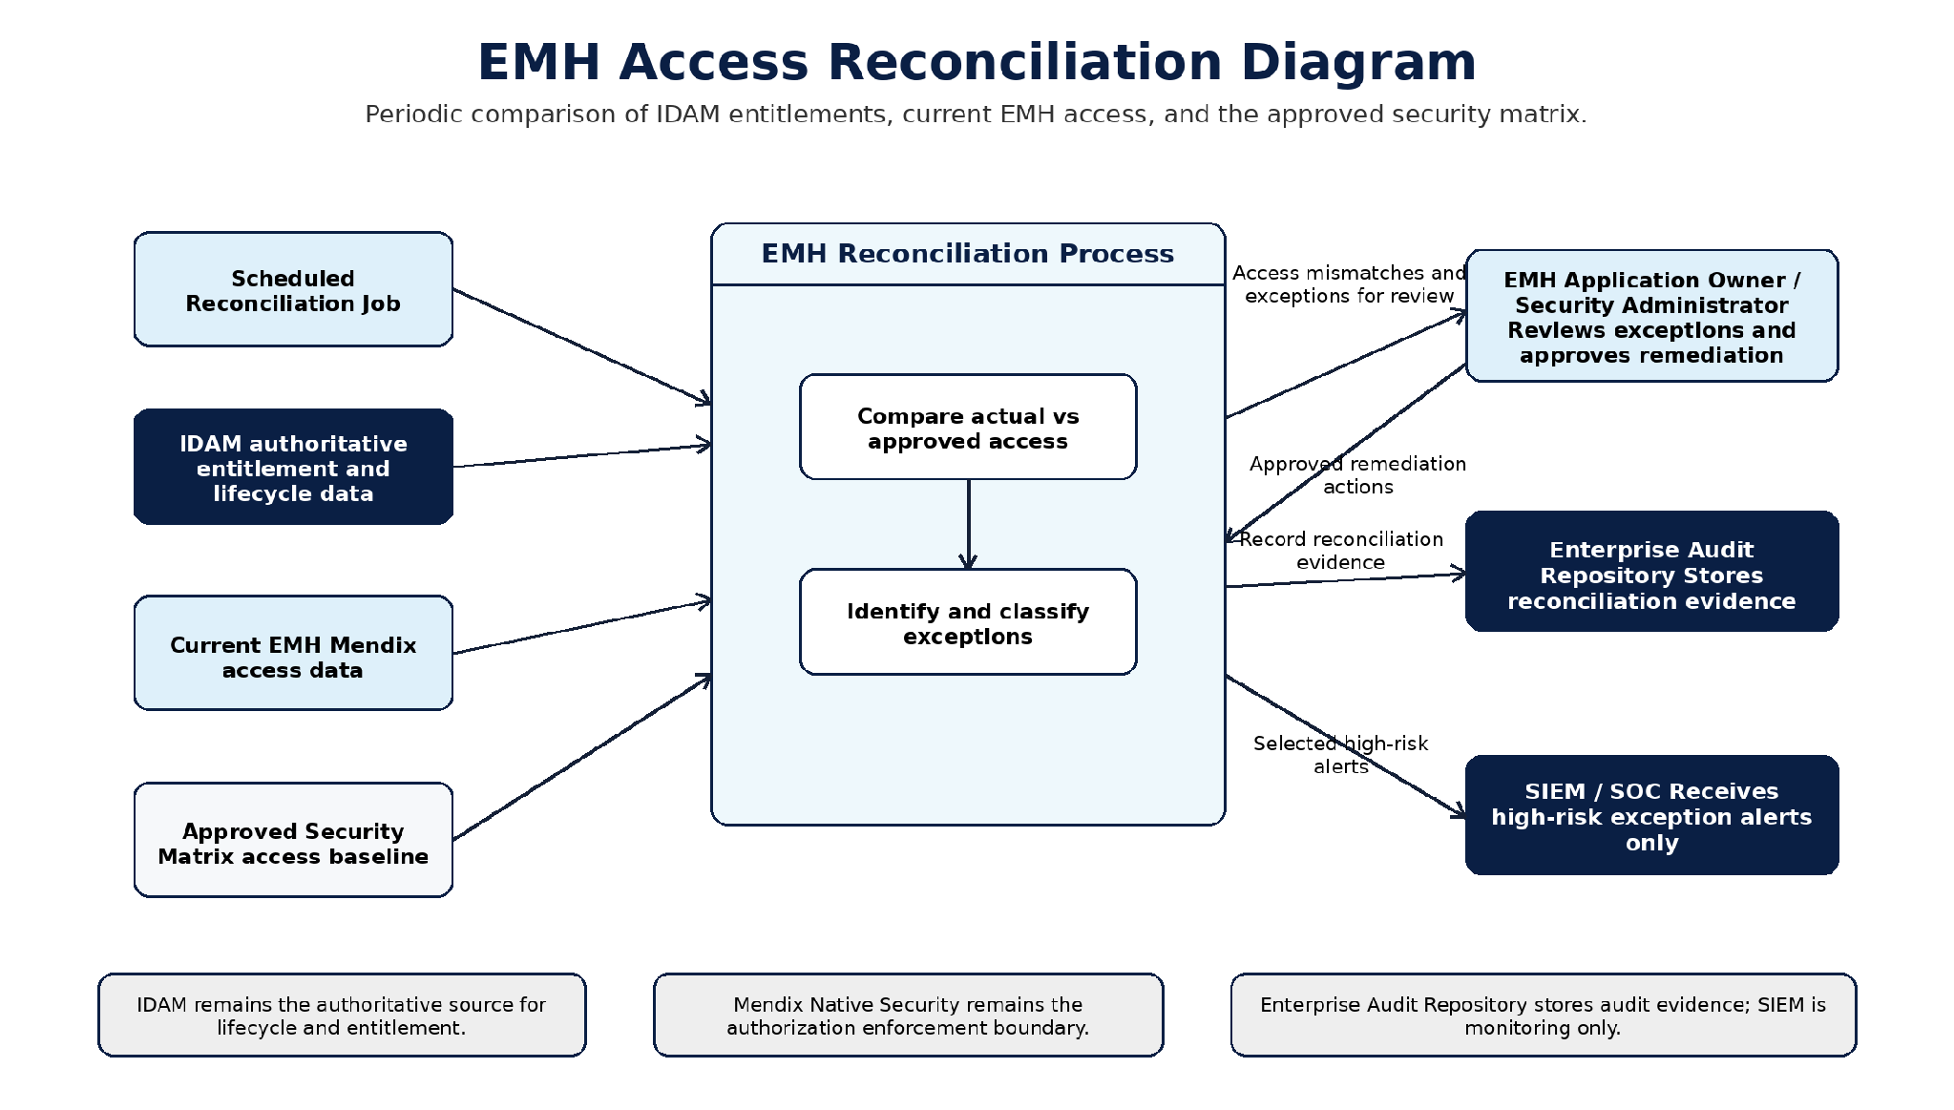
Figure 1: EMH Access Reconciliation Diagram

2.3.2.1 Data Quality Controls
DQ ID | Control Area | Simple Explanation | Type | Implementation Control | Evidence
DQ-01 | Search Validation | Users must enter approved search criteria before EMH calls any source API. This prevents empty or broad searches. | Validity / Privacy | Server-side Mendix microflow validation before API invocation. | SIT negative test evidence.
DQ-02 | API Response Mapping | Data returned by source APIs must be mapped only to approved NPE attributes. | Integrity | Contract-based mapping review and API response test cases. | API mapping test results.
DQ-03 | No Source Data Persistence | EMH must not store patient, clinical, payment, application, search criteria or raw API payload data in the Mendix database. | Data Minimization | Persistable domain model review and code review for create/change operations. | Domain model review evidence.
DQ-04 | No Sensitive Logging | Logs must not contain MRN, Emirates ID, patient data, search values, raw payloads, tokens or credentials. | Privacy / Security | Sanitized exception handling and logging review. | Log review / security test evidence.
DQ-05 | Audit Completeness | Every important support investigation or administrative action must generate a safe audit event without storing sensitive criteria. | Accountability | Audit microflow integration and minimum audit-event validation. | Audit test evidence.
DQ-06 | Correlation ID | Each significant transaction must have a non-sensitive correlation ID to support troubleshooting without exposing patient or search data. | Traceability | Correlation ID generated and passed through API calls, logs and audit delivery flow. | Traceability test evidence.

2.3.3 Data Volume & Sizing
Data Volume & Sizing records the main inputs needed to size the Mendix runtime, source API traffic, audit delivery and operational logging.
Sizing Area | What Must Be Confirmed | Design Position / Guardrail | Architecture Impact | Owner / Gate
Users and concurrency | Named users by role and expected concurrent users. | Performance and release sizing gate. | Mendix runtime sizing | Business / Infrastructure
Search volume | Expected searches per day, peak hour and module mix. | Bounded searches only  no broad or empty searches. | Source API throughput, page response time and user experience. | Business / Source API Owners
API calls and response size | Number of API calls per investigation and maximum approved response size. | Use provider filtering/pagination and timeouts where supported. | Runtime memory, network latency and source-system load. | Integration Team / Source API Owners
Audit events and AuditOutbox | Audit events per search/action and acceptable temporary backlog thresholds. | AuditOutbox is a temporary delivery buffer only. | Audit delivery reliability and operational alerting. | Audit Repository Owner / Operations
Operational logs and monitoring | Expected exception, integration and security-event log volume. | Logs must be structured, sanitized and retained under operations policy. | Exception logging sizing and retention; APM monitoring sizing and retention; SIEM monitoring sizing and retention. | Operations / SOC
Mendix database growth | Growth from platform data, user/account metadata and temporary outbox records only. | Source-system business data does not persist in EMH. | Confirms database sizing is not based on patient/application source records. | DBA / Platform Team

2.3.3.1 Sizing Guardrails
Guardrail | Purpose
Bounded search results | Prevent broad lookup and large UI payloads.
API timeout and retry limits | Protect the Mendix runtime and source systems from slow or repeated calls.
No source-data persistence | Keep the Mendix database limited to platform data and approved temporary operational records.

2.3.4 Data Retention & Archival
EMH does not retain source-system business data. Source API responses, raw request/response payloads and search criteria are used only during authorized request execution and are not persisted in the Mendix database. Retention in EMH is limited to platform-managed data, minimal account mapping where required, temporary AuditOutbox records and operational evidence required for secure support operations. Authoritative retention for audit, logs, security monitoring, secrets and source business data is managed by the relevant enterprise systems.
Record Category | Storage Location | Retention Approach | Owner / Notes
Source API response data and raw payloads | Not persisted in EMH | Runtime request/page context only. Source data and raw technical payloads are not stored in EMH. | Source systems remain authoritative owners.
Search criteria values | Not persisted in EMH | Used only during request execution and not retained after the search action. | Must not be written to logs or audit payloads.
Mendix Account / IDAM mapping | Mendix platform database / minimal approved account attributes | Retained according to account lifecycle and access governance requirements. | IDAM remains the identity system of record; EMH stores only minimal mapping where required.
AuditOutbox records | EMH temporary operational store | Temporary until successful Audit Repository acknowledgement or retry escalation. | Not an audit repository; no patient data, search criteria, raw payloads, tokens, secrets or stack traces.
Exception logs | Elasticsearch / centralized exception logging | Retained according to approved operations logging policy. | Sanitized technical diagnostics only; no sensitive values or raw payloads.
Runtime monitoring metrics | AppDynamics / APM monitoring | Retained according to approved monitoring policy. | Operational performance and availability metrics only; no business payloads.
Security monitoring signals | SIEM and originating authoritative platforms | Retained according to SOC/SIEM security monitoring policy. | Used for security monitoring; SIEM is not the audit system of record.
Mendix database backups | Enterprise backup platform | Retained according to platform backup, RPO/RTO and compliance policy. | Backups contain EMH platform data and temporary operational records only, not source-system business data.

2.3.4.1 AuditOutbox Retention Rules
Rule | Requirement
Temporary delivery buffer only | AuditOutbox is not the audit system of record and must not be used for audit reporting or compliance search.
Remove after acknowledgement | Successfully delivered records are cleaned after acknowledgement from the Audit Repository.
Controlled retry window | Failed delivery records remain only while retry and escalation rules are active.
Alert on backlog or age | Operations must be alerted if pending record count or oldest pending age exceeds the approved threshold.
No sensitive payload | AuditOutbox must not contain search criteria, patient data, clinical data, payment data, API payloads, tokens, credentials, exception messages or stack traces.

2.3.4.2 Exception Log Retention Rules
Rule | Requirement
Storage | Exception logs are retained in Elasticsearch / centralized exception logging, not Mendix DB. APM/runtime monitoring metrics are retained according to the approved monitoring policy.
Purpose | Used for troubleshooting, monitoring, performance analysis and incident response.
Access | Restricted to Operations, SOC and approved technical support roles.
Sanitization | Logs must exclude sensitive identifiers, source API payloads, authentication material and clinical data.
Indexing | Logs should be searchable by timestamp, environment, module, interface, severity, outcome category and CorrelationId.
Lifecycle | Retention and deletion are governed by logging-platform policies.
Audit separation | Exception logs are not audit evidence and must not be used as a substitute for audit completeness.

2.3.5 Data Privacy Compliance
Data privacy controls are embedded into EMH’s data model, integration pattern, display rules, audit delivery and operational logging design. EMH processes personal and healthcare data only for authorized support investigation purposes. Source-system data is retrieved on demand, displayed according to approved access rules, not persisted in EMH after use, and excluded from raw logs, audit payloads and temporary operational records unless explicitly approved.
Privacy Principle | Design Control | Verification
Purpose limitation | EMH functions are limited to approved support investigation modules. | Use-case review and acceptance scenarios.
Data minimization | Only required fields are mapped into NPEs | Domain model, mapping review and database inspection.
Storage limitation | Source-system response data is non-persistable; only AuditOutbox temporarily persisted for audit delivery. | Database inspection after test searches.
Access limitation | Mendix user roles, module roles, page access, microflow access and entity access enforce authorization. | Security matrix and negative-access testing.
Accuracy | EMH displays current source-system data retrieved through approved APIs without local modification or re-mastering. Accuracy is validated through API contract testing, mapping validation and reconciliation checks between EMH views and source-system responses. | API contract and reconciliation tests.
Confidentiality | TLS, secrets management, role restrictions and no-store controls protect data in transit and display. | Security configuration evidence.
Auditability | Privacy-safe audit events record accountability without storing the searched values or source payloads. | Audit sampling and audit completeness tests.
Diagnostic separation | Technical exception logs are stored in Elasticsearch. Runtime performance and availability metrics are monitored in the approved APM platform. Neither contains business payloads. | Log inspection and redaction tests.

3. Application Architecture
The Application Architecture defines the Mendix application structure, module responsibilities, interface design, environment model and application server considerations. EMH is implemented as a modular Mendix monolith. The application uses capability-aligned modules, native Mendix security and controlled REST integrations. The architecture avoids unnecessary distributed services, duplicate authorization databases, direct source-database access and application-managed secret storage.

3.1 Application Context

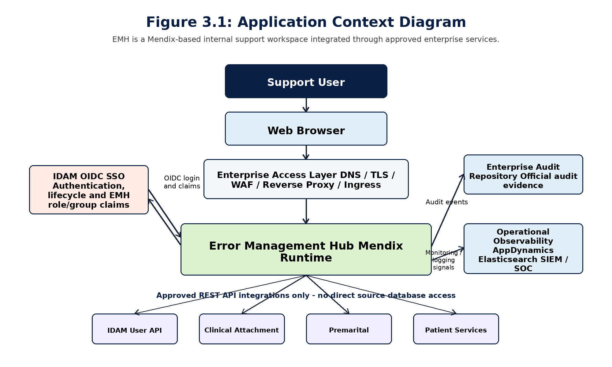

3.2 Component Description
Component | Location | Responsibility | Boundary / Constraint
EMH_Shell | Mendix | Application layout, navigation, landing page and module entry points. | Navigation visibility is not security. Actual authorization is enforced through Mendix roles, page access and microflow access.
EMH_Security | Mendix | SSO integration support, account mapping, role validation helpers and access-denied handling. | Does not authenticate passwords, store tokens or duplicate IDAM lifecycle.
EMH_UserManagement | Mendix | IDAM internal/external user investigation and identity access view where an approved API exists. | Read-only investigation. Source response data is represented through NPEs.
EMH_ClinicalAttachment | Mendix | Clinical Attachment application search, detail/payment view, reference view and responsibility view where an approved API exists. | Read-only. No clinical data is persisted.
EMH_Premarital | Mendix | Premarital application and payment investigation. | Implementation depends on approved source API contracts.
EMH_PatientServices | Mendix | Health Card, Sick Leave and Medical Report request investigation. | Highly sensitive runtime views; no document retrieval or persistence.
EMH_Audit | Mendix | Builds privacy-safe audit events and queues them in AuditOutbox for delivery to the Enterprise Audit Repository. | AuditOutbox is temporary only. EMH does not provide the authoritative audit database.
Mendix Native Security | Mendix platform | Provides users, roles, module roles, page access, microflow access and entity access. | Primary authorization boundary. No parallel permission engine.
IDAM | External | Authentication, identity lifecycle, MFA, account status and identity APIs. | Identity system of record.
Audit Repository | External | Permanent audit storage, search, retention, legal hold and disposal evidence. | Audit system of record.
Elasticsearch | External | Sanitized exception-log indexing and search for runtime errors, integration failures and diagnostic metadata. | Exception logging only; not an audit repository and must not store sensitive business payloads, tokens or credentials.
AppDynamics | External | Application performance monitoring, runtime health, response-time, dependency-latency and availability monitoring. | APM/monitoring only; not the exception-log store and not an audit repository.
Source Applications | External | Business data ownership and processing for Clinical, Premarital and Patient Services. | Systems of record; expose approved APIs only.

3.3 Interface Description
The following summary identifies the external interfaces used by EMH at architecture level. Detailed request/response payloads, error-code mappings, timeout values, pagination rules and provider SLAs remain part of the approved API/interface contracts owned by the relevant provider and integration teams.

3.3.1 Interface Design
InterfaceID | Interface Name | Integration Type | Middleware | Integration Pattern | Logical Data Entity | Trigger | Trigger Description | Quality of Service | Error Handling & Recovery Technique | Regulatory Requirements | Average Message Size in KB | Average Daily Transactions | Peak Hourly Transactions | Performance Requirement in milliseconds | Authentication & Authorization | Notes
IDAM | IDAM | Web Service / OIDC | - | Synchronous Request/Response | User Identity / Claims | User triggered | Login / claim retrieval | Once per login/session | OIDC errors; controlled messages; sanitized logs | Identity compliance | <10KB | TBD | TBD | <1000ms | OIDC Auth Code Flow | Authoritative identity and entitlement source.
CLN | Clinical Attachment | Web Service / REST API | TBD | Synchronous Request/Response | Application / Detail / Payment | User triggered | Search/view application details | On demand | Timeout/error handling; sanitized exception log | Healthcare confidentiality | TBD | TBD | TBD | TBD | Service account / API auth - TBC | Source system of record.
PRE | Premarital | Web Service / REST API | TBD | Synchronous Request/Response | Application / Payment | User triggered | Search/view premarital details | On demand | Timeout/error handling; sanitized exception log | Healthcare confidentiality | TBD | TBD | TBD | TBD | Service account / API auth - TBC | API contract TBC.
MR | Medical Report | Web Service / REST API | TBD | Synchronous Request/Response | Medical Report View | User triggered | Search/view report details | On demand | Timeout/error handling; sanitized exception log | Healthcare confidentiality | TBD | TBD | TBD | TBD | Service account / API auth - TBC | No file storage unless approved.
HC | Health Card | Web Service / REST API | TBD | Synchronous Request/Response | Health Card View | User triggered | Search/view health card details | On demand | Timeout/error handling; sanitized exception log | Healthcare confidentiality | TBD | TBD | TBD | TBD | Service account / API auth - TBC | No source data copy.
SL | Sick Leave | Web Service / REST API | TBD | Synchronous Request/Response | Sick Leave View | User triggered | Search/view sick leave details | On demand | Timeout/error handling; sanitized exception log | Healthcare confidentiality | TBD | TBD | TBD | TBD | Service account / API auth - TBC | No document storage unless approved.

3.3.2 API List
API Name | URI Path | HTTP Method | Provider | Consumer(s) | Description | Status
IDAM Internal User Search |  | POST | IDAM | EMH | Retrieves internal user account/profile details for support investigation. | Existing
IDAM External User Search |  | POST | IDAM | EMH | Retrieves external user account/profile details for support investigation. | Existing
IDAM User Roles Lookup |  | POST | IDAM | EMH | Retrieves source identity role/access information where supported. | Not Available
Clinical Application Search |  | GET | Clinical Attachment | EMH | Retrieves Clinical Attachment application summary results. | Existing
Clinical Application Detail & Payment |  | POST | Clinical Attachment | EMH | Retrieves detailed application status and payment context. | Existing
Clinical ICP Applicant Lookup |  | GET | Clinical / ICP route | EMH | Retrieves applicant information through approved route. | Existing
Clinical Reference Data Lookup |  | POST | Clinical Attachment | EMH | Retrieves facility/specialty reference values where required. | Existing
Clinical Responsibility Lookup |  | POST | Clinical Attachment | EMH | Retrieves responsible team or owner for application handling. | Not Available
Premarital Application Lookup |  | GET | Premarital | EMH | Searches Premarital applications by approved criteria. | Existing
Patient Services Health Card Search |  | TBC | Patient Services | EMH | Retrieves Health Card status and related support details. | Existing
Patient Services Sick Leave Search |  | TBC | Patient Services | EMH | Retrieves Sick Leave certificate status and related support details. | Existing
Patient Services Medical Report Search |  | TBC | Patient Services | EMH | Retrieves Medical Report request status and references. | Existing
Audit Event Acknowledgement | TBC | Response / callback pattern TBC | Audit Repository | EMH | Confirms receipt and authoritative storage of submitted audit events. | TBC
Exception Log Forwarding | TBC | Agent / structured log pipeline | Elasticsearch / Centralized Logging | Mendix Runtime | Sends sanitized runtime and exception diagnostics to operational logging. | TBC
APM Telemetry | TBC | Agent / supported telemetry | AppDynamics | Mendix Runtime | Provides runtime, dependency and performance monitoring. | TBC

3.3.3 Event List
Phase 1 does not introduce a business event bus. Events listed below are application audit, audit-delivery or operational monitoring events. They do not replace source-system business events.
Event Code | Trigger | Persisted? | Minimum Safe Data | Consumer / Use
AUDIT_DELIVERY_STATUS | Audit dispatch process identifies repeated delivery failure, recovery or aging backlog. | Operational telemetry only; material events may generate audit event if required. | Queue depth, oldest event age, attempt count, outcome category, environment, CorrelationId. | Operations monitoring and incident management.
TECHNICAL_EXCEPTION | Runtime, mapping or integration exception requires diagnosis. | No Mendix DB persistence. Stored in Elasticsearch through structured exception logging. The approved APM platform may monitor related error-rate metrics only. | Environment, module, interface code, exception category, safe message, severity, CorrelationId. | Operations troubleshooting and monitoring.
INTEGRATION_TIMEOUT_OR_UNAVAILABLE | External API times out or is unavailable. | No Mendix DB persistence except audit outcome of user action. | Interface code, operation code, duration, outcome category, CorrelationId. | Operations/APM/provider escalation.

3.3.4 Application Server Details
Server / Runtime Aspect | Ip address
Web server

3.4 Application Environments
Business Application | Environment Name | Environment Type | Mendix Deployment | Purpose | Availability | Notes
Error Management Hub | Development | Development | Mendix Runtime on approved on-premises/private platform | Feature development, component testing, connector scaffolding and developer validation. | Internal | Uses synthetic data, mocks or development endpoints only. No production data, production credentials or production audit records are used.
Error Management Hub | Testing | Testing | Mendix Runtime on approved on-premises/private platform | Integration testing, business validation, access testing, security/performance validation and release approval. | Internal / Restricted | Uses synthetic, test or masked non-production data approved by privacy/security.
Error Management Hub | Production | Production | Mendix Runtime on approved on-premises production platform | Live support investigation for authorized Dubai Health users. | Production service window TBC | Uses production source APIs; EMH displays source data transiently and does not persist source responses, documents, exports or raw API payloads.

3.4.1 Environment Mapping
Business Application | Environment Name | Environment Type | Target Business Application / Service | Target Environment & Data Segregation / Integration Notes
Error Management Hub | Development | Development | IDAM | Development/testing identity service only. Test identities are used; production credentials, production identities and production secrets are not used.
Error Management Hub | Development | Development | Clinical Attachment, Premarital, Patient Services and related source APIs | Development, test or mock endpoints only. Synthetic records are used for connector scaffolding and mapping validation.
Error Management Hub | Development | Development | Enterprise Audit Repository, approved APM monitoring, centralized exception logging and SIEM | Development, test or mock operational services only. No production audit records or sensitive payloads are used.
Error Management Hub | Testing | Testing | IDAM | Testing identity service only. Approved test identities are used for SSO, role mapping and negative-access testing.
Error Management Hub | Testing | Testing | Clinical Attachment, Premarital, Patient Services and related source APIs | Approved non-production provider environments only. Synthetic, test or masked data is used unless privacy/security explicitly approve otherwise.
Error Management Hub | Testing | Testing | Enterprise Audit Repository, approved APM monitoring, centralized exception logging and SIEM | Testing operational services only. Test audit events, sanitized diagnostics and approved security signals are used for release validation.
Error Management Hub | Production | Production | IDAM | Production identity service. IDAM remains the authentication and identity system of record. EMH does not store passwords or authentication tokens.
Error Management Hub | Production | Production | Clinical Attachment, Premarital, Patient Services and related source APIs | Production source systems remain authoritative. EMH retrieves and displays source data only for authorized support investigation and does not persist source responses.
Error Management Hub | Production | Production | Enterprise Audit Repository, approved APM monitoring, centralized exception logging and SIEM | Production audit events are retained in the Enterprise Audit Repository. Diagnostics are sanitized. SIEM is used for security monitoring and is not the audit system of record.

4. Technical Architecture
The technical architecture places the Mendix application runtime inside the organization’s private hosting environment. Runtime deployment, databases, ingress, secrets, monitoring, backup and disaster recovery are independently operated platform capabilities. The design must use only versions and deployment modes supported by the approved Mendix subscription and private-platform support matrix.

4.1 Implementation & Deployment View

4.1.1 On-Premises Deployment View
The target is an approved on-premises/private Mendix runtime platform. The final production topology (runtime nodes/replicas, ingress/load balancing, database, storage, secrets, monitoring and backup integration) is confirmed through the platform design gate.
Deployment Element | Recommended Baseline
Container platform | Approved on-premises/private Mendix runtime platform
Mendix operating mode | Approved platform/deployment tooling where supported
Ingress | WAF with approved TLS certificate and hostname
Container registry | Internal registry with controlled import/promotion
Database | Dedicated supported SQL Server baseline
Persistent storage | Only platform/runtime needs and approved future file features
Secrets | secrets manager
Outbound network | HTTPS to approved APIs, IDAM metadata and monitoring destinations (Proxy, firewall ports, DNS, certificate trust and TLS.)
Observability | AppDynamics

4.2 Technology Landscape
TOE Aspect | Production | Non Production
Deployment/Application Service Name | EMH | sama
TOE Version | Dubai Health_IT Standards & Guidelines V3.0.0 | Dubai Health_IT Standards & Guidelines V3.0.0
Deployment P  Deployment Pattern  attern | On-Prem(Low-Code) | On-Prem(Low-Code)
Hosting Location(Region) | UAE | UAE
Service Tier | TBD | Not applicable

4.3 Technical Services / Components
Application Component / Business Application | SubComponent | Technical Service / Component | EMH Boundary / Constraint
Error Management Hub | Presentation | Mendix responsive web shell, module landing pages, search pages, result/detail pages, masking, access-denied and unavailable states.
Error Management Hub | Business Logic | Mendix microflows and limited nanoflows for validation, orchestration, API invocation, mapping, safe errors and audit-event preparation. | Security-sensitive behavior remains server-side; source-system updates are out of scope.
Error Management Hub | Integration | Consumed REST connectors using EMH_IntegrationCommon for correlation ID propagation, timeout handling, error classification, redaction and mapping support. | Approved APIs only; no direct source-database access and no unmanaged local provider cache.
Error Management Hub | Data / Database | Mendix database stores platform data in SQL db, minimal account mapping and temporary AuditOutbox records only. | No patient records, clinical records, payment records, documents, exports, search criteria or raw API payloads are persisted.
Error Management Hub | Audit | EMH_Audit creates privacy-safe audit events and uses AuditOutbox only as a temporary delivery buffer to the Enterprise Audit Repository. | Enterprise Audit Repository remains the audit system of record; AuditOutbox is not used for reporting or legal retention.
Error Management Hub | Logging / Monitoring | Sanitized runtime diagnostics and integration metrics are emitted to approved APM monitoring and centralized exception logging platforms. | Operational diagnostics are not audit evidence and must not contain sensitive values or raw payloads.
Error Management Hub | Security | IDAM OIDC authentication, native Mendix roles, module roles, page access, microflow access and entity access. | No custom permission engine, no password storage and no local authentication token table.
Error Management Hub | Configuration / Secrets | Non-secret runtime configuration through approved environment/deployment mechanisms; credentials and certificates through secret-management services. | No secrets in model constants, source control, application database, packages or logs.
Error Management Hub | Backup / DR | Platform-managed database backups, approved application artifact retention and redeploy/restore recovery process. | Source-system data is not backed up by EMH; source systems retain their own data and continuity responsibilities.

4.4 Implementation Details
Implementation Topic | Mendix Approach | Mandatory Constraint
Module boundaries | One business module per investigation domain; shared modules expose narrow services | No direct cross-module use of private entities/flows without documented interface.
Naming | Prefix modules/entities/microflows by capability; use ACT_, SUB_, INT_, VAL_, DS_, SCH_ conventions | Detailed names are confirmed during detailed design and controlled change management.
Microflows | Small orchestration flows with explicit inputs/outputs and centralized error translation | Security-sensitive work remains server-side.
Nanoflows | Client-only UX such as clearing fields, toggling panels and non-sensitive formatting | No authorization, credentials or authoritative business logic.
External data | NPE import mappings and page context | Never commit source operational data.
Transactions | Keep persistence transactions short and never hold a transaction across an external call | Write the audit event in a bounded transaction after the action outcome is known. Runtime logging remains independent of the audit transaction.
Error handling | Map failures to a safe user message and emit sanitized diagnostics to the runtime log | Do not persist exception text, stack traces, request/response bodies or credentials in AuditOutbox / Audit Event or any business entity.
Configuration | Environment-specific endpoints, timeouts, native security configuration and release/deployment controls | No secrets in constants; changes controlled and audited.
Search results | Pagination/bounded results, explicit no-result state and source freshness | Default maximum 30 displayed records pending contract.
Scheduled tasks | Retention and optional reference refresh only | Cluster-safe single execution and idempotency must be proven for multi-replica deployment.

4.4.1 High Availability
High availability for EMH is driven by the approved service target and the production platform design. EMH should be deployed so that runtime, ingress, database, SSO, audit delivery, monitoring and source-interface dependencies are resilient. If an external provider is unavailable, EMH should degrade only the affected module while keeping unrelated modules usable.
Application / Component | Composite SLA | Sub Component | Technical Service / Component | Availability Target | EMH High-Availability Design
Error Management Hub | TBC - aligned to approved business availability target | Presentation | Mendix responsive web application behind enterprise ingress/WAF | TBC | Use approved ingress/load-balancing, TLS/certificate monitoring and health routing. Navigation failure must not expose sensitive data.
Error Management Hub | TBC - aligned to approved business availability target | Business Logic | Mendix runtime / capability modules | TBC | Use multiple runtime instances/replicas where approved by platform and licensing. Keep modules independent so provider failure affects only the related module.
Error Management Hub | TBC - aligned to approved business availability target | Integration | IDAM, source APIs, Enterprise Audit Repository and logging/SIEM integrations | Provider SLA / TBC | Apply timeout, one approved idempotent retry, correlation ID, safe error classification and module-level graceful degradation.
Error Management Hub | TBC - aligned to approved business availability target | Database | Dedicated Mendix SQL Server database | TBC | Use enterprise SQL HA/backup pattern where approved. Database contains platform data and temporary operational records only, not source-system business data.
Error Management Hub | TBC - aligned to approved business availability target | Audit & Operations | AuditOutbox, approved APM monitoring, centralized exception logging and SIEM | TBC / platform policy | AuditOutbox provides temporary delivery buffering only. Monitoring alerts must cover runtime health, API failures, audit backlog and logging pipeline issues.

4.4.2 Data Backup & Recovery
Backup and recovery for EMH covers Mendix platform data, minimal account metadata, temporary AuditOutbox records, application, configuration references and operational evidence. EMH does not back up source-system business data, medical reports, clinical attachments, exports or raw API payloads because these are not stored in EMH.
Backup Object | Frequency / Retention | Recovery Evidence
Mendix database | Must satisfy approved RPO | Point-in-time restore test and integrity checks.
Application package | Every release | Redeploy approved rollback and current approved versions.

Data Integrity Issue | Description | Data Backup Strategy | Mitigation via Application Design | Data Recovery Strategy
Malicious activity or unauthorized access | Attempted unauthorized change, misuse or compromise affecting EMH platform data or configuration. | Encrypted platform/database backups and immutable release artifacts retained by enterprise platform teams. | Least privilege, PAM/MFA for admins, WAF, SIEM monitoring, no source payload persistence and sanitized logs. | Contain access, rotate secrets, restore from trusted backup/artifact and validate audit/security evidence.
Scheduled or unscheduled maintenance | Maintenance may temporarily affect runtime, database, ingress, IDAM, APIs, audit repository or logging services. | Use approved maintenance/backout plan and pre-maintenance backup where platform policy requires. | Communicate service window, use module-level unavailable states and keep unrelated modules independent where possible. | Restart/redeploy service, verify database connectivity, SSO, source APIs, audit delivery and monitoring after maintenance.
System or process failure | Runtime, database, deployment, logging, audit delivery or source-interface failure. | Maintain database backups, release artifacts, configuration records and runbooks. Source-system data remains backed up by its owner. | Timeouts, controlled retry, AuditOutbox backlog alerting, safe errors and correlation IDs for troubleshooting. | Restore database or redeploy approved artifact, replay/retry pending audit delivery where valid, and execute smoke tests.
Natural disaster or site-level outage | Loss of primary platform, database or connectivity at hosting location. | Enterprise backup/DR policy covers database, artifacts, configuration references and secrets recovery process. | EMH stores no source-system business data; recovery scope is limited to EMH platform state and temporary operational records. | Activate approved DR/redeploy process, restore database to approved RPO, reapply configuration/secrets references and validate service.

4.4.3 Disaster Recovery
The EMH disaster-recovery approach is based on restoring the approved Mendix runtime, database, application artifact, configuration references and secrets access, then validating SSO, source-interface connectivity, audit delivery and monitoring. RTO and RPO remain subject to approved business and infrastructure confirmation; source-system business data recovery remains owned by the respective source systems.
Category | Details
Application Component/Business Application | EMH
RTO (Recovery Time Objective) | TBD: 1 hour
RPO (Recovery Point Objective) | TBD:5 Minutes
DR Strategy | Redeploy on disaster
Dependency Management | End-Users and Administrator won't be able to access the system during transition period. Also, there is possibility of data loss in acceptance with RPO

4.4.4 Logging & Monitoring
Signal | Source | Destination | Content / Privacy Rule | Alert Example
Audit event | EMH_Audit microflow / AuditOutbox dispatcher | Enterprise Audit Repository; optional selected security copy to SIEM | Event category, action, module, actor reference, outcome, UTC time, source-system code and correlation ID only. No criteria, payload, personal/clinical/payment data or exception details. | Undelivered audit events, unusual denied access or administration pattern
AuditOutbox delivery status | EMH AuditOutbox dispatcher | Approved APM monitoring platform; approved sanitized delivery diagnostics platform where required | Queue depth, oldest event age, attempt count, status category and correlation ID. No audit payload content. | Audit repository outage, aged pending events or repeated delivery failures
Exception/runtime log | Mendix Runtime and EMH_Operations | Elasticsearch / centralized exception logging platform | Severity, environment, component, exception type, sanitized message and correlation ID. No source payload, tokens, credentials or search values. | Repeated exception, startup failure or error-rate threshold
HTTP/APM metric | Ingress and runtime agent | AppDynamics / enterprise APM monitoring platform | Request rate, duration, status class and resource use; no query values or payload. | P95 response time, 5xx rate or saturation threshold

4.5 DevSecOps
DevSecOps governs the model, custom extensions, dependencies, configuration, build artifact and deployment path. A Mendix application still requires disciplined source control, peer review, automated quality checks, environment segregation and release evidence.
Continuous integration (CI) is the practice of merging all developer code into a central codebase frequently, and then performing automated build and test processes. The objectives are to quickly discover and correct code issues, to streamline deployment, and to ensure code quality. We will use Azure Devops to maintain our code base.
Continuous delivery (CD) is the practice of automatically building, testing, and deploying code to production-like environments. The objective is to ensure that code is always ready to deploy. Adding continuous delivery to create a full CI/CD pipeline helps you detect code defects as soon as possible. It also ensures that properly tested updates can be released in a short time. Azure Pipelines will be leveraged for deployment when Necessary quality gates have been passed.
Continuous monitoring refers to the process and technology required to incorporate monitoring across each phase of DevOps and IT operations lifecycle. Monitoring helps to ensure the health, performance, and reliability of your application and infrastructure as the application moves from development to production. Continuous monitoring builds on the concepts of CI and CD.

5. Information Security Architecture
Security is based on IDAM authentication and role entitlement, native Mendix authorization enforcement, minimized transient data, secure API connectivity, on-premises deployment, platform hardening and auditable operations. Front-end visibility is not treated as a security control: every page, microflow and entity must have explicit access rules, and every external service uses a read-only technical identity with least privilege.

5.1 Information Resource Management Assessment
IRM Domain | Assessment / Control Position | Evidence / TBC
Information classification | Identity and health-related content is Confidential/Highly Confidential; operational metadata classification TBC | Approved classification and field matrix.
Residency | Application, persisted data, backups and logs remain in approved UAE/on-premises locations | Infrastructure/data-flow attestation.
Ownership | Source systems own business data; EMH owner governs app configuration/events | Data mastership and signed owner matrix.
Access | SSO plus least-privilege Mendix roles and segregated admin/platform access | Security matrix and access review.
Retention | External data is transient; persisted evidence follows approved policy | Compliance decision and purge test.
Third parties | Mendix/vendor support, Marketplace modules and any external operations access must be assessed | Contracts, data access conditions and support model TBC.
Continuity | Provisional RTO/RPO and redeploy/restore plan | Approved BIA, DR design and exercise.

5.2 Assurance
Business Application | Assurance
Mendix | - SOC 1 Type II  - SOC 2 Type II  - PCI DSS V4 Level 1  - ISO 22301 Certification-DR  - ISO/IEC 27001:2022 Certification: Security Related  - ISO/IEC 27017 Certification-Security Related  - ISO/IEC 27018 Certification-PII Related  - HIPAA
EMH assurance combines inherited platform/vendor assurance, approved on-premises platform controls and project-specific application evidence. No independent EMH product certification is claimed by this document; any inherited platform certifications must be evidenced through current approved vendor and platform assurance packs.

5.3 Segregation
Segregation Area | Required Separation | Control
Environments | Production separated from development/test by namespace/project, credentials, database, endpoints and access | No production secrets/data in non-production.
Application roles | Viewer, Application Support, Application Administrator, Auditor and EMH Security Administrator | Module roles grant only required pages/flows/entities.

5.4 Identity & Access Management
IDAM authenticates the user, controls the enterprise account lifecycle and remains the authoritative source for EMH access groups or role claims. EMH defines the approved Mendix user roles and module roles, registers the corresponding EMH access groups or claims in IDAM, and maps the returned OIDC claims to native Mendix roles during login or approved provisioning synchronization. Authorization enforcement inside EMH is performed by native Mendix security, including user roles, module roles, page access, microflow access and entity access. EMH does not implement a separate custom authorization database or permission table.

5.4.1 Identity Management
Identity Function | Owner | Design
Authentication | IDAM | Enterprise SSO; OIDC confirmed. IDAM performs password, MFA, lockout and identity proofing.
OIDC token validation | Mendix SSO integration/runtime | Validate issuer, client/audience, signature, token expiry and nonce/state controls according to the supported OIDC configuration.
User matching | Mendix | Map stable IDAM subject/NameID to the Mendix Account; email is not the sole immutable key. Approved IDAM role/group claims are mapped to the corresponding native Mendix user roles and module roles.
Provisioning | IDAM + Mendix OIDC/provisioning mapping | EMH roles are defined in Mendix and registered in IDAM as approved application groups or role claims. Just-in-time or synchronization-based account/role provisioning updates native Mendix account-role associations. Disabled users must lose access promptly.
Attributes | IDAM | Minimum claims only: stable subject, display name/email as needed, account status where approved, and approved EMH group/role claims used for Mendix role mapping.
MFA ( phase 2) | IDAM | No custom MFA in EMH

5.4.2 Access Management
Control | Mendix Implementation | Rule
Application user roles | Granular Mendix user roles and module roles, for example UserManagementSupport, ClinicalAttachmentSupport, PremaritalSupport, PatientServicesSupport, Auditor, SecurityAdministrator and ApplicationAdministrator. Corresponding EMH access groups or role claims are registered in IDAM. | Final role catalogue is approved during security and detailed design sign-off. IDAM assigns users to approved EMH groups/claims; Mendix enforces access after mapping those claims to native roles. No custom permission tables are introduced.
Module roles | Per module: Viewer/Support/Admin where needed | Only roles with a business need receive module access.
Page access | Explicit by module role | No sensitive page exposed to a broad role.
Microflow access | Explicit by module role | All search/admin/retention flows server-authorized.
Entity access | Read/write XPath/access rules for persistable entities; NPE access restricted by module role | No write access to audit events for ordinary users; no broad sensitive entity exposure.
Navigation | Mendix role-based navigation and page access. | Navigation hiding is usability only; server-side microflow/entity access remains authoritative.
Search criteria | Allowed keys/formats per function and role | No unbounded/bulk search.
Access review | Periodic review of IDAM EMH groups/claims, mapped Mendix user roles, module roles and privileged access. | Review must reconcile IDAM entitlement with native Mendix account-role associations and the approved Security Matrix.
Revocation | Remove or disable the user in IDAM, or remove the user from approved EMH groups/claims; EMH removes or makes ineffective the mapped Mendix roles according to the approved synchronization/session policy. | Revocation must prevent access on next login, role synchronization event or session revalidation. Maximum propagation time is TBC and must be tested.

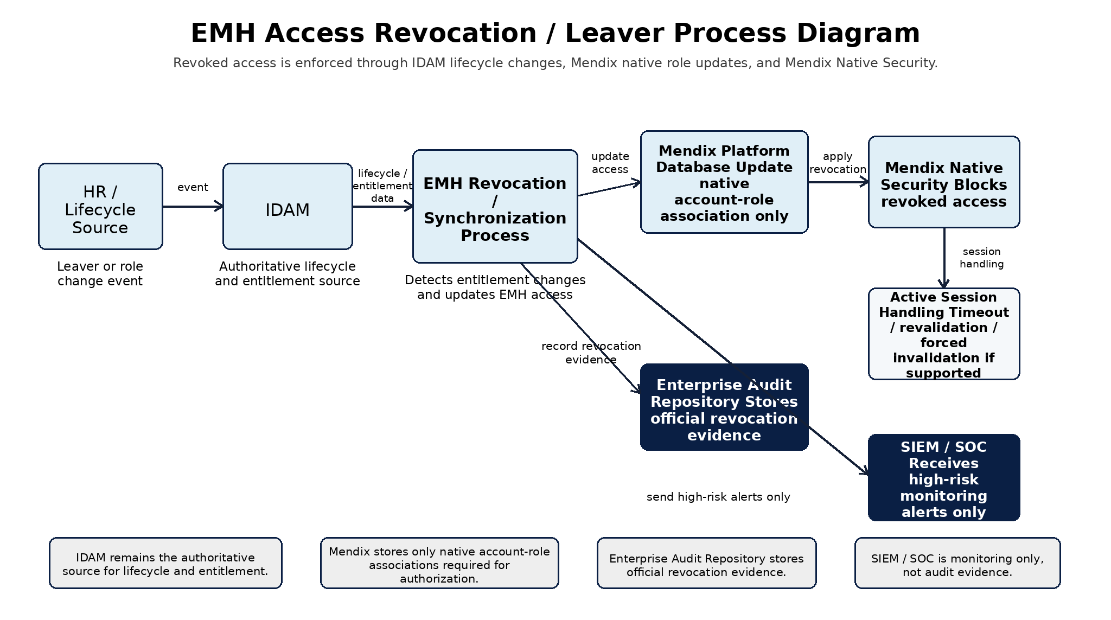
Figure 3: EMH Access Revocation / Leaver Process Diagram

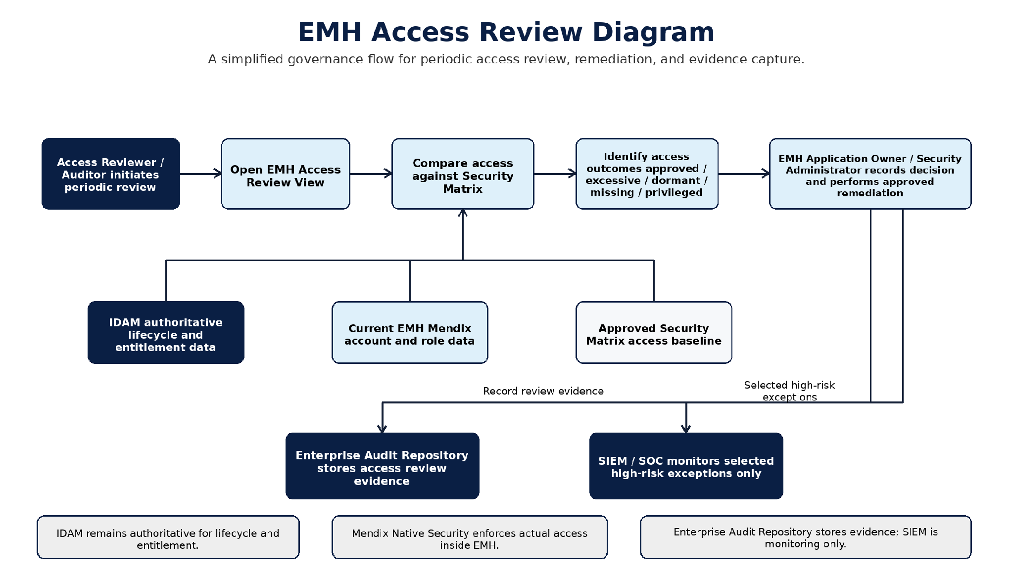
Figure 4: EMH Access Review Diagram

5.4.3 Privileged Access Management
Privileged Role | Permitted Activities | Controls
Mendix Platform Administrator | Manage deployment environment and runtime configuration | PAM, MFA, named account, change ticket and full audit.
Production Deployer | Promote approved artifact/configuration | Pipeline-only where possible; cannot approve own change.
Database Administrator | Backup, restore, performance and controlled maintenance | No business browsing; monitored privileged session.
Secrets / PKI Administrator | Create/rotate secrets and certificates | Dual control for critical keys where policy requires.
EMH Security Administrator | Administer approved EMH access process, validate IDAM-to-Mendix role mapping and correct native Mendix role associations where authorized. | Separate from support role; changes follow approved process, are audited and reconciled with IDAM groups/claims.
EMH Application Administrator | Manage approved operational administration, release/deployment controls and safe configuration | Cannot change model-time security or platform secrets.
Auditor | Read audit/security evidence | Read-only and independent from record creation/configuration.
Break-glass Administrator | Emergency recovery only | Time-bound credential, incident approval, alerting and after-action review.

5.5 Vulnerability Management
Vulnerability management covers the Mendix platform/runtime, Marketplace dependencies, custom Java/widgets, container/base components, ingress, database and host/cluster. Findings are triaged by exploitability, data sensitivity and exposure, with a defined remediation SLA and exception process.

5.5.1 SAST
(Static Application Security Testing)

Static application security testing (SAST) is applicable for Low Code Development.Even though no-code platforms abstract much of the coding process, the underlying code generated can still have security flaws. SAST tools can help identify these vulnerabilities early in the development process.

Scope | Method | Gate
Custom Java actions/modules | Approved SAST tool on source and build artifact where available | No unaccepted critical/high finding.
Custom JavaScript/widgets | SAST/lint/dependency review including DOM/XSS risks | No unsafe dynamic code or secret exposure.

5.5.2 SCA

Software composition analysis (SCA) is an automated process that identifies the open source software in a codebase. For Low Code Development SCA will be applicable.as low code platform rely on various libraries and components. SCA tools can help track these dependencies and ensure they are up-to-date and secure. and also that all third-party components comply with licensing requirements.

Dependency Class | Control | Evidence
Marketplace modules | Approved source, supported version, license and known-vulnerability review | Dependency register and approval.
Custom Java libraries | Pinned versions, repository allow-list and SCA scan | SBOM/dependency report and remediation.
Custom widget/npm dependencies | Lock file, SCA scan and minimal dependency set | No critical/high unaccepted issue.
Operational agents | AppDynamics/logging/security agents supported with runtime/platform | Compatibility and vulnerability evidence.

5.5.3 DAST
DAST (Dynamic Application Security Testing)
DAST, also called Penetration Test (Pentest) is an attempt to evaluate the security of an IT infrastructure by safely trying to exploit the vulnerabilities. We will do a PEN test once we are in production along with business approval on a need basis.

Test Area | Minimum Scenarios | Constraint
Unauthenticated surface | Direct URL, SSO endpoint behavior, headers, redirects and information disclosure | Do not attack IDAM without owner authorization.
Authenticated authorization | Cross-role page/microflow/entity access, parameter tampering and forced browsing | Use dedicated test identities.
Input handling | Search fields, headers, query/path values and error behavior | No production testing without approval.
Session | Logout, idle/absolute timeout, replay, concurrent session and revocation | Aligned with IDAM/Mendix supported behavior.

5.6 Encryption

5.6.1 Encryption at Rest
Asset | Control | Key Management

5.6.2 Encryption in Transit
Connection | Requirement
Browser to ingress | HTTPS; TLS 1.3 preferred where supported
Mendix to IDAM/APIs | HTTPS; TLS
Mendix to database | Encrypted SQL connection with certificate validation (forces the application to validate the database server’s identity against trusted certificates, preventing man-in-the-middle attacks)

5.7 Connectivity & Integration

Encryption of network connections using TLS 1.3, this is mandatory for all network connections.
DLP (Data Loss Prevention) also called prevention of Data exfiltration This is used to detect accidental data loss and prevent malicious data exfiltration on social networks, file sharing, and storage applications across the internet.

Control | Requirement
Network allow-list | Only required inbound browser/SSO paths and outbound API, database, registry, monitoring, secrets and platform endpoints.
No direct DB access | EMH cannot connect to IDAM, Clinical, Premarital or Patient Services databases.

5.8 Business Continuity

Covered in Sections High Availability, Data Backup & Recovery and Disaster Recovery

5.9 Logging & Monitoring

Mendix Logging will be utilized for all deployments along with Open Shift Cluster using ELK.

5.10 Security Incident Management
DAHC Standards reporting process will follow for any kind of incident.

5.11 Threat Modeling & Mitigation Design Choices
Threat modelling for EMH focuses on protecting identity, healthcare information, support investigation activity, source-system integrations, audit delivery and operational telemetry. EMH remains a read-only investigation workspace; source systems remain authoritative and EMH does not store source-system business data.
Recommendations to Application Developer
• Enforce encryption for all EMH data stored or backed up by the approved platform, and use TLS-secured protocols with certificates issued by a trusted certificate authority.
• Perform static and dynamic security testing on the EMH application, including Mendix model review, SAST/SCA for custom components and authenticated DAST before production release.
• Allow approved third-party penetration testing or independent security testing where required by Dubai Health governance.
• Do not write sensitive information to logs, browser storage, URLs, error messages, clipboard or temporary files. This includes MRN, Emirates ID, patient data, clinical data, payment data, raw payloads, tokens and secrets.
• Do not store confidential source-system data locally in the browser or in the Mendix database. Source-system data must remain runtime-only and non-persisted.
• Use IDAM SSO and MFA according to enterprise policy. EMH must not handle, store or transmit user passwords outside the approved IDAM authentication flow.
• Use approved enterprise secret management for API credentials, certificates and service authentication material. Do not store secrets in Mendix constants, database tables, source repository or operational logs.
• Validate Mendix native security through negative tests covering user roles, module roles, page access, microflow access and entity access.
Threat Area | EMH Mitigation / Design Choice
Spoofing / authentication abuse | Rely on IDAM SSO, OIDC token validation, MFA policy, secure session handling and least-privilege Mendix roles.
Tampering / unauthorized changes | Use server-side validation, fixed endpoint configuration, controlled deployment changes and administration audit events.
Information disclosure | Use NPE-first design, masking, no local source-data persistence, no bulk export and sanitized logs.
Denial of service / slow providers | Apply bounded search criteria, timeouts, one approved retry, module-level graceful degradation and operational alerts.
Elevation of privilege | Use Mendix native page, microflow and entity access; navigation hiding is not treated as security.
Supply-chain weakness | Review Marketplace modules, custom Java/actions/widgets and dependencies through approval, SCA and secure release gates.
Secrets exposure | Use approved secret-management services and certificate/secret rotation; no plaintext secrets in model, DB, repo or logs.

5.12 Privacy by Design
Privacy is implemented through the data model and processing path rather than added as a reporting control. The application receives only the fields needed for a defined support function, keeps them transient, restricts and masks display, and records only safe operational metadata.

5.12.1 Personal Data Flow
1. An authorized user authenticates through IDAM; EMH receives only approved identity claims and EMH role/group claims required to establish the session, account mapping and native Mendix role mapping.
2. The user opens a permitted investigation page and enters one or more approved search criteria.
3. A server-side microflow validates the criteria, generates a correlation ID and invokes the fixed approved API endpoint.
4. The source system searches its authoritative data and returns a bounded response over encrypted connectivity.
5. Mendix maps the response into non-persistable entities, applies role/display rules and shows the result.
6. EMH places a minimized audit event in AuditOutbox for delivery to the Audit Repository without the searched value or response payload.
7. When the page/session context ends, the non-persistable response is discarded; browser/proxy caching is restricted as approved.

5.12.2 Personal Data Usage
Data Category | Permitted Use
Identity identifiers | Locate and diagnose account/status/link issues
Contact details | Identify correct user/result and diagnose account setup
Clinical attachment data | Show current application/payment/responsibility state
Premarital data | Show current application/payment state
Patient-service data | Show health card, sick leave or medical-report data

5.12.3 Third-Party Processing
Third Party / Provider | Potential Role | Data Exposure | Required Control
Mendix vendor support | Platform support provider | Potential metadata/support artifacts; production data access should be avoided | Contract/DPA, support-access process, residency and sanitized diagnostic package.
Marketplace component publisher | Software supplier, not intended processor | No runtime data unless component behavior sends data externally | Source/reputation review; prohibit telemetry/external calls unless approved.
AppDynamics / APM monitoring platform | Operational telemetry processor/platform | Sanitized runtime and HTTP performance metrics | On-prem/local deployment and retention/access confirmation.
Elasticsearch / exception logging platform | Sanitized exception-log processor/platform | Sanitized exception messages, error metadata and diagnostic correlation IDs | No sensitive search values, patient data, clinical data, payment data, tokens, credentials or source payloads.
External API owners | Independent internal system owners/providers | Receive search criteria and return authoritative data | Purpose, service identity, contract, audit and ownership.
Infrastructure/DB operations | Internal processor/administrator | Persisted configuration/audit and encrypted backups | PAM, confidentiality, least privilege and audit.

5.12.4 Security Considerations

Section Encryption at Rest
Section Encryption in transit,
Design decisions related to PAM need to be included in Section Privileged Access Management

5.12.5 User Privacy Considerations
Consideration | Requirement
Notice | Support users are informed that searches are for authorized support purposes and are audited.
Minimum display | Pages show only fields required for the task and role.

6. Implementation Approach
Implementation is planned as controlled, evidence-based delivery by a single Mendix implementer. The implementation plan below is simplified for architecture approval and shows estimated active implementation effort per step. It does not include waiting time for external approvals, infrastructure provisioning, IDAM configuration, source API readiness, security review, or business sign-off.

6.1 Implementation Roadmap and Estimated Timeline
The timeline assumes one full-time implementer working on application structure, Mendix configuration, module implementation, integration mapping, testing support and documentation updates. One additional working day has been added to each step as a planning buffer.
Step | Implementation Stage | Main Activities | Expected Duration - Single Implementer | Key Dependency / Exit Gate
1 | Confirm and Prepare | Confirm scope, module list, source/API owners, security matrix, OIDC claims, access roles, environments and delivery assumptions. | 4-6 working days | No unresolved blocker for OIDC, platform access or source API design.
2 | Build EMH Foundation | Create Mendix application structure, modules, navigation shell, common layout, configuration structure, shared UI patterns and common error handling. | 6-8 working days | Basic app shell runs in the development environment.
3 | Implement OIDC Login and Native Security | Configure IDAM OIDC login, account matching, role/claim mapping, Mendix user roles, module roles, page access, microflow access, entity access and access-denied behavior. | 8-11 working days | Login, logout, role mapping and negative-access tests pass.
4 | Implement Audit and Logging Pattern | Build privacy-safe audit event structure, AuditOutbox pattern, correlation ID generation, sanitized exception handling and operational logging hooks. | 6-9 working days | Audit events are generated without search values, payloads, tokens or sensitive data.
5 | Build User Management Module | Implement search page, validation, IDAM API connector, NPE mapping, result/detail views, masking, error handling, audit events and tests. | 8-11 working days | User Management module accepted by the module owner.
6 | Build Clinical Attachment Module | Implement Clinical Attachment search, detail, payment and responsibility views where approved; build API mappings, NPEs, masking, unavailable states, audit events and tests. | 11-16 working days | Clinical APIs are available and the module owner accepts the output.
7 | Build Premarital Module | Implement Premarital application and payment lookup, approved search criteria, NPE mapping, display rules, audit events and tests. | 8-13 working days | Premarital API contract and test data are available.
8 | Build Patient Services Module | Implement Health Card, Sick Leave and Medical Report inquiry views, approved API mappings, masking, no-document-storage controls, audit events and tests. | 13-19 working days | Patient Services APIs and approved fields are confirmed.
9 | Integration and End-to-End Testing | Execute end-to-end flows across OIDC login, role mapping, source API calls, audit, logging, unavailable states, masking and negative access. | 8-11 working days | SIT evidence completed.
10 | Security, Privacy and Performance Hardening | Fix issues from testing, verify no sensitive logging, validate access controls, review masking, run performance checks and prepare evidence. | 8-11 working days | No open critical/high security or privacy finding.
11 | UAT and Business Validation Support | Support UAT, fix defects, refine screens/messages and validate module outputs with support users and owners. | 6-11 working days | Business owner and module owners accept.
12 | Go-Live Preparation and Hypercare | Prepare deployment checklist, smoke tests, support guide, rollback approach, production validation and initial hypercare. | 4-6 working days | Production smoke test and handover accepted.

6.1.1 Total Expected Timeline for One Implementer
The estimates below represent active implementation effort. Calendar duration can increase if external dependencies are not ready when required.
Estimate Type | Duration | Meaning
Best-case active implementation effort | 12-15 weeks | Assumes stable requirements, ready environments, approved OIDC details and available source API contracts.
Realistic active implementation effort | 14-18 weeks | Allows normal defect fixing, clarification, UI refinement and test-cycle support for one implementer.
Calendar duration including dependency waiting | 16-22+ weeks | Includes expected delays from external teams, approvals, source-system readiness, security reviews or production change windows.

6.1.2 Timeline Assumptions and Exclusions
The estimate is based on one full-time Mendix implementer. It covers EMH application configuration, module development, mapping, testing support and documentation updates. The following activities are dependencies owned by other teams and are not included in the active implementation duration:
• Infrastructure provisioning, DNS, certificates, firewall rules, database setup, backup and monitoring platform readiness.
• IDAM OIDC application registration, approved claims, lifecycle rules and IDAM-side role/group assignment.
• Source API development, API gateway onboarding, service authentication, test data preparation and provider acceptance.
• Enterprise Audit Repository onboarding, acknowledgement pattern, retention decision and operational ownership.
• AppDynamics monitoring platform setup, retention and alert configuration.
• Elasticsearch exception logging platform setup, retention and alert configuration.
• SIEM platform setup, retention and alert configuration.
• Security, privacy, IRM, architecture review board, production change approval and business sign-off waiting time.

6.1.3 Deployment, Cut-over and Hypercare Approach
Deployment and cut-over are intentionally kept simple for Phase 1 because EMH does not migrate source-system business data. The go-live approach is controlled release, smoke testing, role enablement and short hypercare.
Cut-over Step | Required Action | Minimum Evidence
1. Freeze release candidate | Freeze the approved Mendix package, configuration version and dependency versions after UAT, security and operational acceptance. | Release candidate reference and approval record.
2. Confirm production readiness | Confirm ingress/DNS/certificate, database, secrets, IDAM, source APIs, audit repository, logging, monitoring, backup and support contacts. | Production readiness checklist.
3. Deploy through approved pipeline | Deploy the immutable release through approved deployment tooling and avoid manual rebuilds in production. | Deployment log and rollback artifact.
4. Execute smoke tests | Validate runtime health, database, OIDC login, role mapping, safe logs, audit event generation and each enabled source interface. | Technical and business smoke-test evidence.
5. Enable modules and hypercare | Enable modules and IDAM-to-Mendix role mappings in a controlled sequence, monitor errors and user feedback, and apply rollback/disabling where required. | Hypercare log and operations handover acceptance.

6.1.4 Data Handling During Implementation and Cut-over
No source identity, clinical, premarital, patient, payment, document or historical case data is migrated into EMH. EMH changes the investigation channel only: source systems remain authoritative, and EMH retrieves source data at runtime through approved APIs.
Data Area | Implementation Approach | Validation
Source-system business data | No migration or copy into Mendix. Query source APIs at runtime only. | API mapping and reconciliation tests against approved source responses.
Identity and authorization data | No credential copy. OIDC claims are mapped to native Mendix roles and module roles. | OIDC/provisioning test, role-mapping approval and negative-access tests.
Configuration and reference data | Seed only approved low-risk configuration or reference values where required. | Configuration review, owner approval and rollback record.
Test data | Use synthetic, anonymized or masked non-production data only. | Privacy/security approval and test coverage evidence.
Audit and operational evidence | EMH starts its own audit evidence at go-live; historical audit remains with existing authoritative owners. | Audit test evidence and owner/compliance confirmation.
Any later request to copy historical cases, personal data, source payloads or documents requires a separate data-handling design, privacy assessment, retention decision, reconciliation plan and cut-over rehearsal. It is not implied by this Phase 1 proposal.

Appendices

Appendix A: Terms & Abbreviations
Term/Abbreviation | Description
EMH | Error Management Hub; the Phase 1 Mendix support investigation workspace.
Mendix | Low-code application platform selected for the EMH application.
IDAM | Identity and Access Management provider used for enterprise authentication and account lifecycle.
SSO | Single Sign-On.
OIDC | OpenID Connect; confirmed protocol for IDAM SSO.
MFA | Multi-Factor Authentication controlled by IDAM policy.
UAE PASS | External identity service consumed by EMH where approved APIs are available.
ICP | External authoritative source used for applicant or identity-related lookup where approved APIs are available.
NPE | Non-persistable Entity in Mendix; used to hold runtime API responses without storing source-system business data.
API | Application Programming Interface.
MRN | Medical Record Number; treated as a sensitive identifier/data element, not as an EMH-owned data object.
EID | Emirates ID; treated as a sensitive identifier/data element.
AuditOutbox | Temporary Mendix delivery buffer used only to deliver minimized audit events to the Enterprise Audit Repository.
Enterprise Audit Repository | Authoritative audit system of record for EMH audit events.
SIEM | Security Information and Event Management platform used for approved security monitoring signals.
IRM | Information Resource Management assessment.
SAST | Static Application Security Testing.
SCA | Software Composition Analysis.
SIT | System Integration Testing.
UAT | User Acceptance Testing.
RTO | Recovery Time Objective.
RPO | Recovery Point Objective.

Appendix B: Solution Detailed Design
Detailed design artefacts are maintained by the delivery team outside this Architecture Proposal. This appendix records only the project-relevant high-level login sequence needed to clarify authentication, OIDC role/group claim mapping, session establishment and native Mendix authorization boundaries.
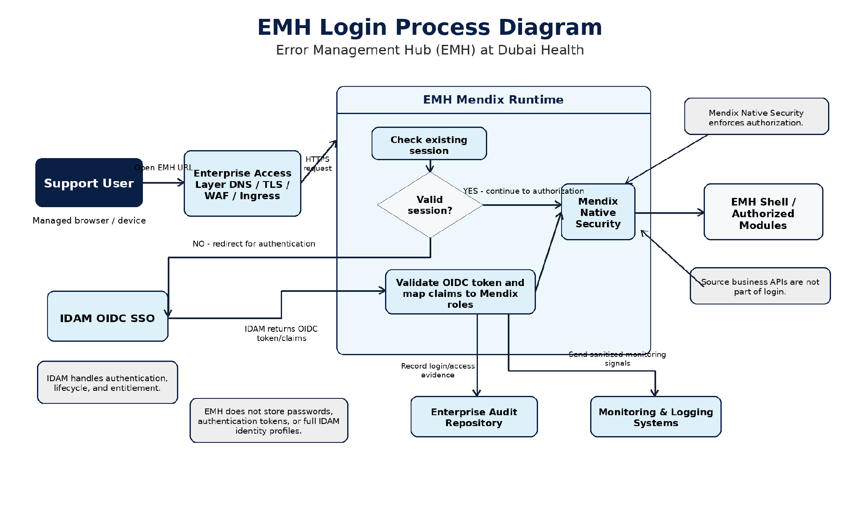
Figure 2: EMH Login Process Diagram

B.1 Login Sequence
1. The authorized user navigates to the EMH URL through the approved enterprise access path.
2. If no valid Mendix session exists, EMH redirects the browser to IDAM using the approved OIDC SSO configuration.
3. IDAM authenticates the user, applies enterprise MFA/account policies and returns only the approved minimum identity claims plus approved EMH role/group claims.
4. Mendix validates the OIDC response, maps the stable IDAM subject to the Mendix Account and maps approved IDAM role/group claims to native Mendix user roles and module roles.
5. Native Mendix account-role associations are stored by the Mendix platform and used with page access, microflow access and entity access to determine what the user can access.
6. The EMH shell displays only navigation and module entry points permitted by the approved IDAM-to-Mendix role mapping and Mendix security model.
7. Search modules invoke source APIs only after role checks and input validation have passed.
8. Logout, session timeout and access revocation follow the approved IDAM lifecycle and Mendix session/role synchronization policies.

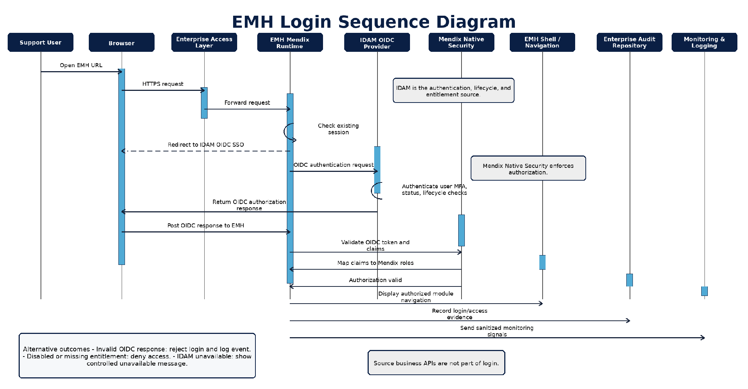
Figure 5: EMH Login Sequence Diagram

B.2 ACRONYMS AND DEFINITIONS
Serial Number | Acronym | Definition
1 | ADR | Architecture Decision Record
2 | API | Application Programming Interface
3 | APM | Application Performance Monitoring
4 | ARB | Architecture Review Board
5 | CI/CD | Continuous Integration / Continuous Delivery
6 | DAST | Dynamic Application Security Testing
7 | DB | Database
8 | DR | Disaster Recovery
9 | EID | Emirates ID
10 | ELK | Elasticsearch, Logstash and Kibana logging stack
11 | EMH | Error Management Hub
12 | HA | High Availability
13 | IDAM | Identity and Access Management
14 | ICP | Federal Authority for Identity, Citizenship, Customs and Port Security integration/source route where approved
15 | IRM | Information Resource Management
16 | MFA | Multi-Factor Authentication
17 | MRN | Medical Record Number
18 | NPE | Non-Persistable Entity in Mendix
19 | PAM | Privileged Access Management
20 | PKI | Public Key Infrastructure
21 | RPO | Recovery Point Objective
22 | RTO | Recovery Time Objective
23 | OIDC | OpenID Connect
24 | SAST | Static Application Security Testing
25 | SCA | Software Composition Analysis
26 | SIEM | Security Information and Event Management
27 | SIT | System Integration Testing
28 | SOC | Security Operations Center
29 | SSO | Single Sign-On
30 | TLS | Transport Layer Security
31 | UAT | User Acceptance Testing
32 | UAE PASS | UAE national digital identity service consumed where approved

Appendix C: Architecture Plan
The architecture plan for EMH is limited to the approved Phase 1 read-only support investigation scope. Future scope changes must follow architecture governance and are not implied by this document.
Architecture Item | Current Plan / Status
Phase 1 baseline | Mendix read-only support investigation workspace with SSO, role-based access, source API lookup, masking, audit delivery and operational monitoring.
Blocking confirmations | Approved source API contracts, Audit Repository integration details and production platform topology remain controlled TBC items. IDAM uses OIDC for login. IDAM returns the required user identity details and approved EMH access roles/groups, and EMH maps them to native Mendix roles.
Future scope | Source-system updates, bulk export remain out of scope unless separately approved.

Appendix D: Architecture PoCs
No project PoC is documented as mandatory within the current v1 Architecture Proposal. If Dubai Health architecture governance requests a PoC, it should be recorded and approved using the table below.
PoC ID | PoC Name | PoC Description | Linked Architecture Decision | PoC Outcome
N/A | No PoC defined for current v1 scope | No formal PoC has been documented as mandatory in this Architecture Proposal. | N/A | To be updated only if a PoC is formally requested.

